Inducer Tutorial 1

The aim of this tutorial is to give you familiarity with using the basic facilities and also some of the more advanced facilities of the Inducer classification workbench. The screenshots are all taken from Inducer version 5.6. They are likely to vary a little from one version of the system to another.

Start Inducer, selecting 'advanced interface'.

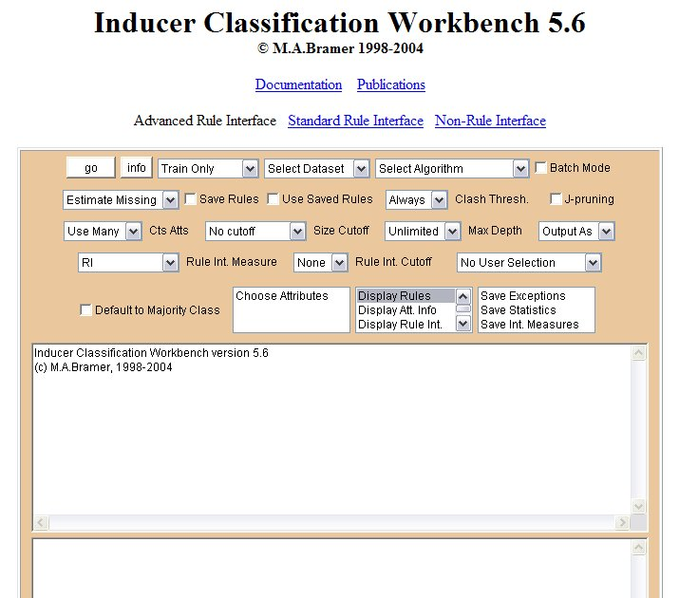

Click on 'Select Dataset' in the top row of the rectangular display and choose dataset lens24. This is a small dataset with four attributes, all of them categorical, three classes and just 24 instances.
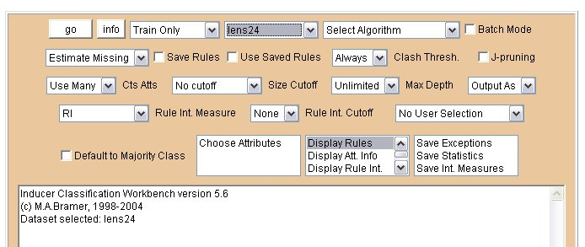

Click on the 'info' button to display information about system settings and user-selected options. These are displayed in the lower of Inducer's two text areas.

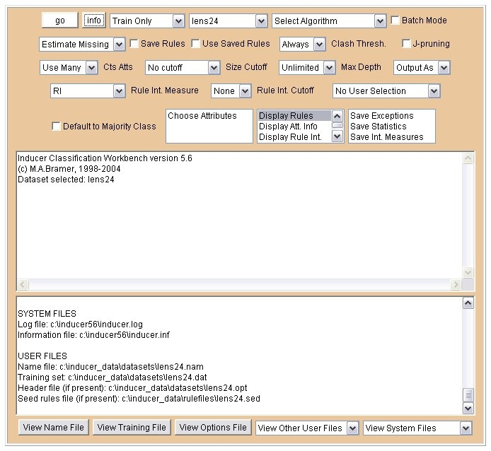

Under DATA INPUT PARAMETERS you will see that the dataset selected is lens24. Most of the information output will probably not be very helpful to you at present.

Go back to the top row of the display, click on 'Select Algorithm' and choose 'TDIDT (entropy)'. Leave the mode selection box (to the right of the info button) unchanged as 'Train Only'.

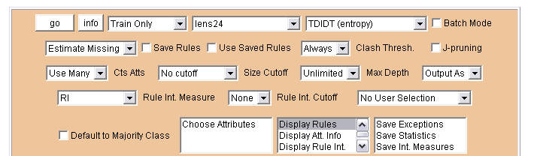

Press the go button. Inducer will execute the TDIDT algorithm with attribute selection using entropy for the dataset lens24. Output appears in both Inducer's upper and lower text areas.

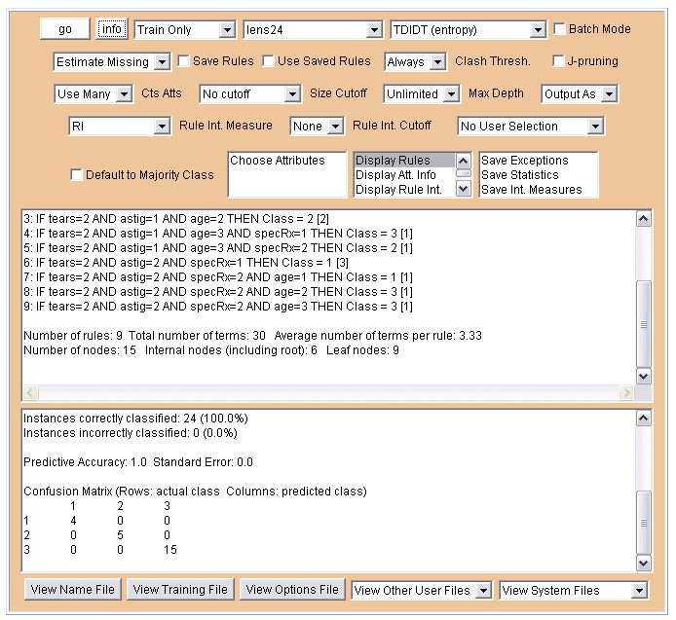

In the upper text area there is basic information about the dataset selected followed by the nine rules generated by the TDIDT algorithm and some further information.

Dataset: lens24
Attributes: categorical 4 continuous 0 ignore 0 (total 4)

'Train Only' selected.
Algorithm: TDIDT Attribute Selection Method: entropy

1: IF tears=1 THEN Class = 3 [12]
2: IF tears=2 AND astig=1 AND age=1 THEN Class = 2 [2]
3: IF tears=2 AND astig=1 AND age=2 THEN Class = 2 [2]
4: IF tears=2 AND astig=1 AND age=3 AND specRx=1 THEN Class = 3 [1]
5: IF tears=2 AND astig=1 AND age=3 AND specRx=2 THEN Class = 2 [1]
6: IF tears=2 AND astig=2 AND specRx=1 THEN Class = 1 [3]
7: IF tears=2 AND astig=2 AND specRx=2 AND age=1 THEN Class = 1 [1]
8: IF tears=2 AND astig=2 AND specRx=2 AND age=2 THEN Class = 3 [1]
9: IF tears=2 AND astig=2 AND specRx=2 AND age=3 THEN Class = 3 [1]

Number of rules: 9 Total number of terms: 30 Average number of terms per rule: 3.33
Number of nodes: 15 Internal nodes (including root): 6 Leaf nodes: 9

In the lower text area there is a listing of the number of classes, attributes and instances, the frequency of each class and the 'majority class' (i.e. the one with most instances). This is followed by the number of training instances correctly and incorrectly classified by the rules and the predictive accuracy of the classifier. In this case all instances were correctly classified, so the predictive accuracy is 1.0. As the rules were induced from the training data this is hardly surprising.

The final item is a 'confusion matrix', which summarises the number of instances in the training set that have each possible combination of actual class value and class value that is predicted by the rules. In this case all the non-zero values are on the diagonal running from the top left-hand corner to the bottom right-hand corner of the matrix, i.e. the training data is perfectly classified by the rules. As was pointed out previously, this is hardly a surprising result, but it provides some reassurance that the rule induction algorithm has worked correctly. The main value of rule induction is to predict the classification of unseen instances that were not used when generating the rules. This topic will be covered later in the unit.

Number of Classes: 3
Number of Attributes: 4

Training Set: lens24.dat
Number of Instances: 24
Number of occurrences of class 1 is: 4 (17%)
Number of occurrences of class 2 is: 5 (21%)
Number of occurrences of class 3 is: 15 (63%)
Majority Class: 3

Training Set: lens24.dat
Instances correctly classified: 24 (100.0%)
Instances incorrectly classified: 0 (0.0%)

Predictive Accuracy: 1.0 Standard Error: 0.0

Confusion Matrix (Rows: actual class Columns: predicted class)
1 2 3
1 4 0 0
2 0 5 0
3 0 0 15

Now go to the fifth row of the screen display, where 'Display Rules' is highlighted (i.e. selected). Click on 'Display Att. Info' to highlight it and click on 'Display Rules' to deselect it. Then press the go button.

This time the rules disappear from the upper text area.

Dataset: lens24
Attributes: categorical 4 continuous 0 ignore 0 (total 4)

'Train Only' selected.
Algorithm: TDIDT Attribute Selection Method: entropy

Number of rules: 9 Total number of terms: 30 Average number of terms per rule: 3.33
Number of nodes: 15 Internal nodes (including root): 6 Leaf nodes: 9

The lower text area is augmented by information about the four attributes stored for the lens24 dataset.

The following text has been added between the lines 'Majority Class: 3' and 'Training Set: lens24.dat' in the lower text area:

Distribution of Attribute Values
Attribute: age
Value: 1 frequency 8 (33%) Value: 2 frequency 8 (33%) Value: 3 frequency 8 (33%)
Most frequent value: 1
Attribute: specRx
Value: 1 frequency 12 (50%) Value: 2 frequency 12 (50%)
Most frequent value: 1
Attribute: astig
Value: 1 frequency 12 (50%) Value: 2 frequency 12 (50%)
Most frequent value: 1
Attribute: tears
Value: 1 frequency 12 (50%) Value: 2 frequency 12 (50%)
Most frequent value: 1

Click on 'Display Att. Info' to deselect that option and click on 'Display Rules' to select that again. Now select the 'Save Statistics' option.

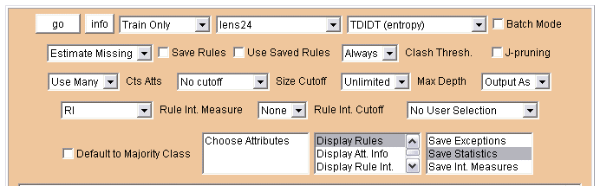

Now press the go button. The nine rules will be output as before but the Inducer system will also save information about the performance of the rules generated to a text file named lens24.sts, which you will be able to read subsequently. The file will be saved to your hard disc in directory c:\inducer_data\outfiles\.

Now go to the row of buttons at the bottom of the screen display.

Press the View Name File button to open the text file lens24.nam, the 'name file' for dataset lens24.

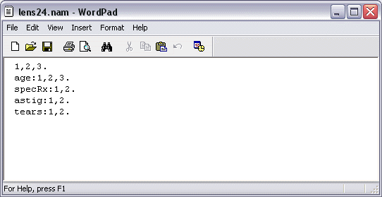

The first row gives a list of the three possible classifications. The following rows give a specification of each of the four attributes in turn. In this case all the attributes are categorical, so the specification of each one is simply a list of all its possible values.

Press the X in the top-right hand corner of the box to close the name file. Click on View Training File to open the text file lens24.dat, the 'training file' for dataset lens24, which has 24 rows.

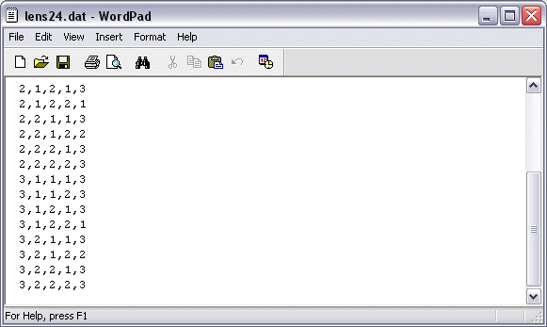

Each of the 24 instances is listed on a separate row of the file. For each instance the values of the four attributes are given, followed by the classification.

Now close the training file.

In order to read the Statistics file that was just created, start by clicking on 'View Other User Files'. A menu appears.

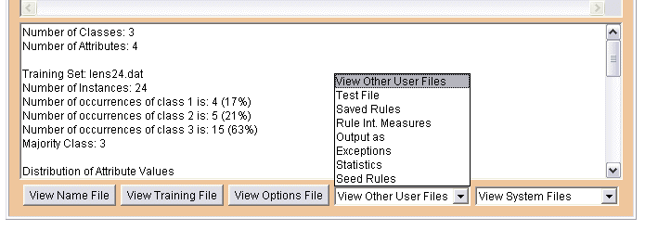

Click on Statistics. The file lens24.sts opens.

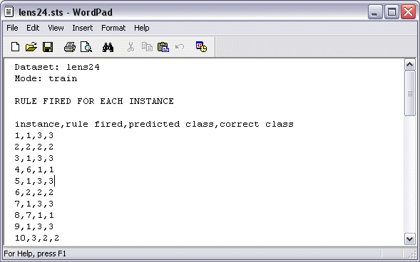

A description of the contents of Inducer Statistics files is given as an appendix to this document. Look briefly at the contents of file lens24.sts, then close it and deselect the 'Save Statistics' option.

The next facility to be illustrated is the Save Rules option. Check the Save Rules box and press the go button. Inducer will give the same screen output as before but will also save a text file lens24.rls to your hard disc in directory c:\inducer_data\rulefiles\.

Go to the bottom of the screen display, click on 'View Other User Files' and select Saved Rules from the menu. The file lens24.rls will open.

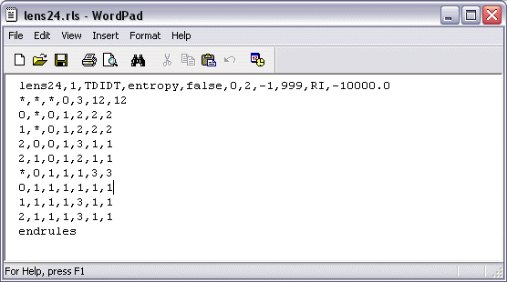

The file contains the nine induced rules in coded form, preceded by a header line and followed by 'endrules'. Now close the saved rules file.

The saved rules for dataset lens24 can be used for classification either now or in a subsequent session. To use them in the same session it is first necessary to uncheck the Save Rules box. Now check the Use Saved Rules box. Note that several of the other boxes now become 'greyed out'. These are options relating to rule generation. As we are using the saved rules, the rule generation stage will be skipped and any rule generation options already selected are no longer applicable. Now press the go button. Inducer uses the pre-stored rules to process the training data.

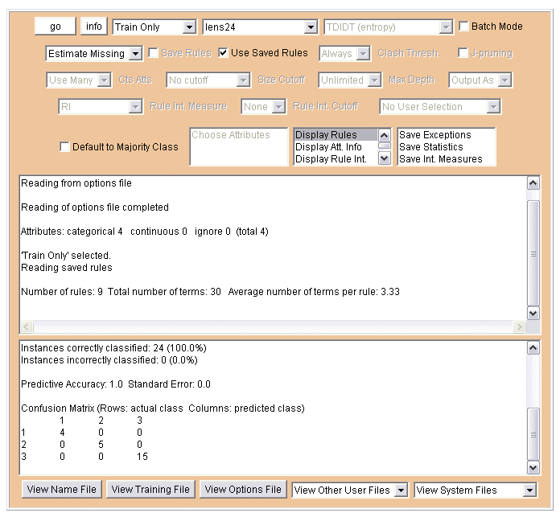

All the training data is correctly classified by the saved rules (as before, this is not at all surprising). Now uncheck the Use Saved Rules box.

The final Inducer facility that will be demonstrated in this tutorial is the 'export' facility. Click on the 'Output As' box to produce a menu.

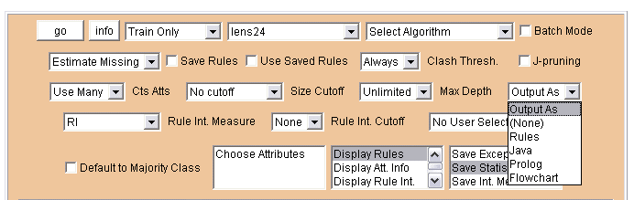

Select Java from the menu and press the go button to run Inducer. This time the system writes a text file lens24.out to the hard disc in directory c:\inducer_data\outfiles\.

Click on 'View Other User Files' and select 'Output as' from the menu.

File lens24.out will open.

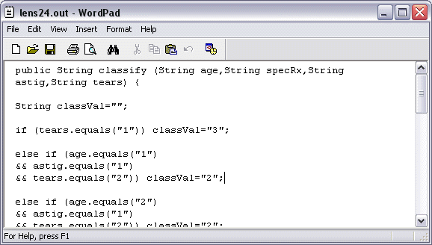

It contains a Java method corresponding to the nine rules in the upper window of the Inducer display. These can be exported from the package into the user's Java programs by simple cutting and pasting. Other 'Output As' options include exporting rules as clauses in the programming language Prolog.

Close file lens24.out and close the web browser to exit from Inducer.
Appendix: the contents of Inducer Statistics files

(a) For each instance

- a numerical reference number (counting from one)

- the number of the rule that fired, i.e. was used to generate a classification for the instance

- the predicted class, i.e. the classification generated

- the correct classification.

(b) For the entire ruleset, its performance on the complete training set

- the number of correctly classified, incorrectly classified and unclassified instances

- the confusion matrix

(c) For each rule, its classification performance on the instances in the training set, i.e.

- a numerical reference number (counting from one)

- the classification corresponding to the rule

- the number of times the rule fired, i.e. was used to classify an instance for which the correct classification was each of the possible classes in turn

- the number of instances for which the rule fired that were correctly classified

- the number of instances for which the rule fired that were incorrectly classified

- the total number of instances for which the rule was fired.

