Inducer Tutorial 2

The aim of this tutorial is to examine more of the facilities of the Inducer classification workbench. The screenshots are all taken from Inducer version 5.6. They are likely to vary a little from one version of the system to another.

Start Inducer, selecting 'advanced interface'. Select dataset crx, which has a training set with 690 instances and a separate test set with 200 instances.

Select 'train and test' mode from the mode selection menu.

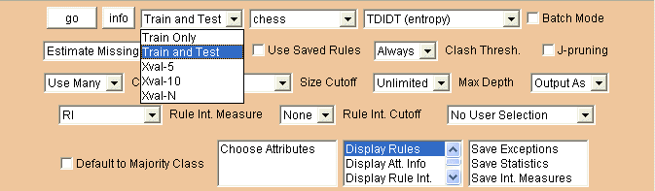

Then press the 'go button'.

Inducer will display 139 rules in the upper text area and then information about the results obtained from using those rules to classify the instances in the training set and test set respectively. For the training set, all 690 training instances are correctly classified, which gives some reassurance that the TDIDT algorithm is implemented correctly but little more. The interesting result is that all 200 of the instances in the test data are also correctly classified – an excellent result.

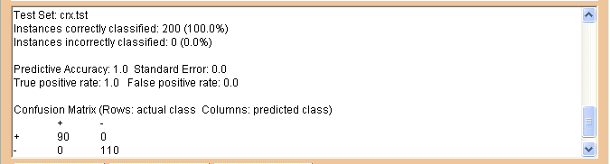

The information displayed in the lower text area also shows that there are missing values in 37 instances in the training set and 12 instances in the test set. Inducer's default setting is to deal with these using the 'Estimate Missing' approach, i.e. to replace missing values by the most frequently occurring value (for a categorical attribute) or the average value (for a continuous attribute). An alternative approach is to use the 'Discard Missing' strategy, i.e. to discard any instances for which there is at least one missing value.

Now select 'Discard Missing' as the missing value strategy.

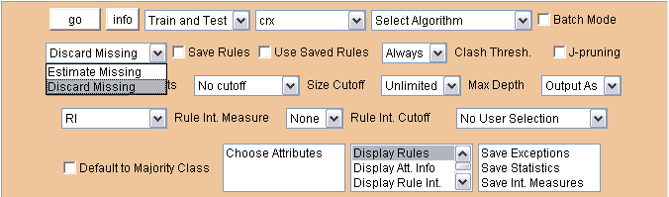

Then press the 'go' button. How did the results compare with the 'Estimate Missing' strategy in this case? Now restore the original missing value strategy, i.e. 'Estimate Missing'.

So far the 'Select Algorithm' facility has not been used. Click on it to produce a menu.

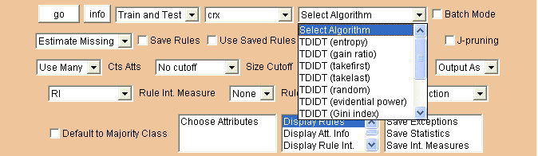

The first option is 'TDIDT (entropy)', i.e. TDIDT with attributes selected using the 'maximise information gain' criterion. This is the default.

Try selecting 'TDIDT (gain ratio)' and 'TDIDT (Gini index)' in turn to see how the classification results for 'Train and Test' mode compare with those for 'TDIDT (entropy)'.

Now go to the menu of datasets and select 'chess' to replace 'crx'. Restore the choice of algorithm to 'TDIDT (entropy)'.

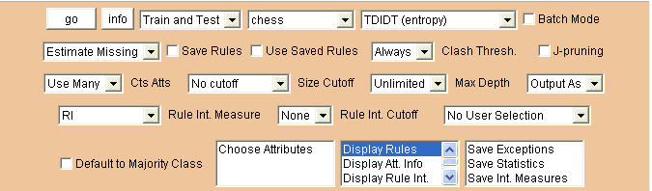

The chess dataset has 647 instances in the training set but no separate test set. As 'Train and Test' mode has been selected pressing 'go' will first cause the data in the training set (effectively) to be divided into two parts, in the approximate ratio 2 to 1: 432 for training and 215 for testing. A message is displayed in the upper text area to indicate this.

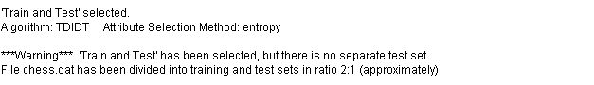

The output in the lower text area shows that the 18 classification rules generated correctly classify all but one of the test instances.

Now return to the mode selection menu and select Xval-5 (i.e. 5-fold cross-validation), Xval-10 (10-fold cross-validation) and Xval-N (N-fold cross-validation) in turn, pressing the 'go' button for each of these selections. (Note that the rules generated are not displayed for these selections.)

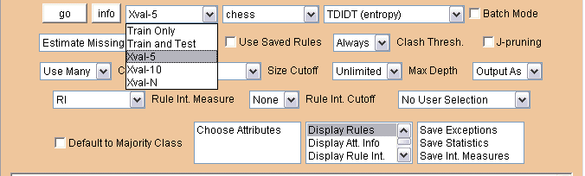

For each type of cross-validation Inducer gives a confusion matrix in the lower text area. For five-fold cross-validation this is as follows.

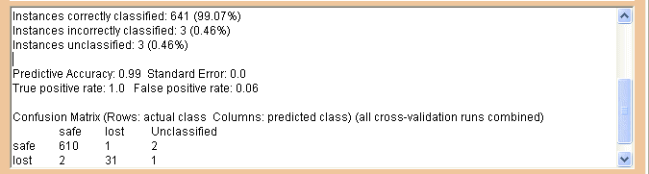

How much do the results vary for 10-fold and N-fold cross-validation?

Now select dataset hypo and 'Train and Test' mode.

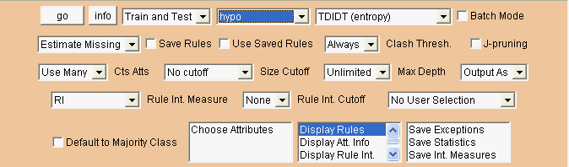

The hypo dataset has a training set of 2514 instances (all of which have at least one missing value) and a test set of 1258 instances (371 of which have missing values). Pressing the 'go' button now produces 15 classification rules which correctly classify all but seven of the instances in the test set.

We can see the interestingness measures associated with these 15 rules by selecting the 'Display Rule Int.' option.

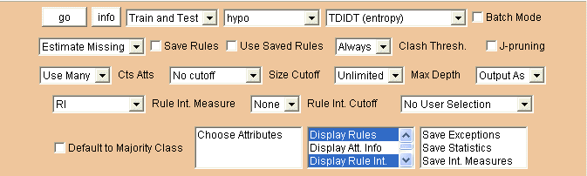.
Pressing the 'go' button now produces the same 15 rules, each one followed by an interestingness value such as [RI = 0.07716787].

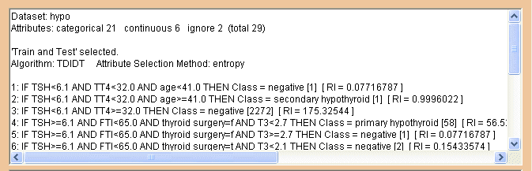

The default rule interestingness measure is RI. To select an alternative measure such as support use the Rule Int. Measure menu.

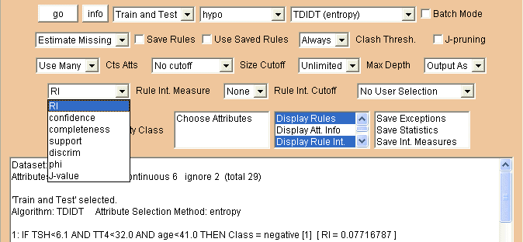

Pressing 'go' now gives the support for each rule.

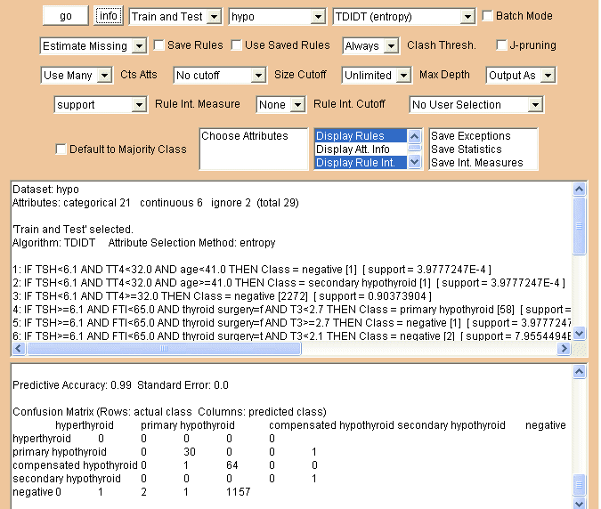

In order to find the values of all the rule interestingness measures calculated by Inducer, the simplest approach is to select the 'Save Int. Measures' option.

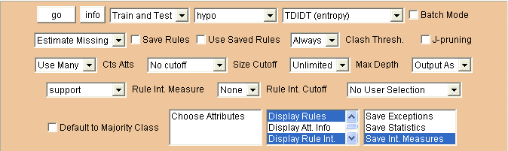

Pressing 'go' now generates the same screen output as before but also creates a 'rule interestingness measures' file (hypo.mes). If the data files are in directory c:\inducer_data\datasets\ (the default location) file hypo.mes will be in directory c:\inducer_data\outfiles\. The file can be read within the package by using the 'View Other User Files' option at the bottom of the screen display.

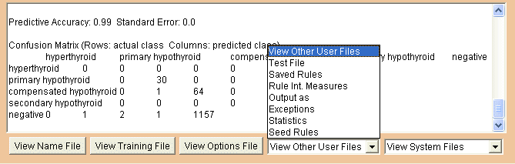

Selecting Rule Int. Measures now causes the file hypo.mes to open in a separate window.

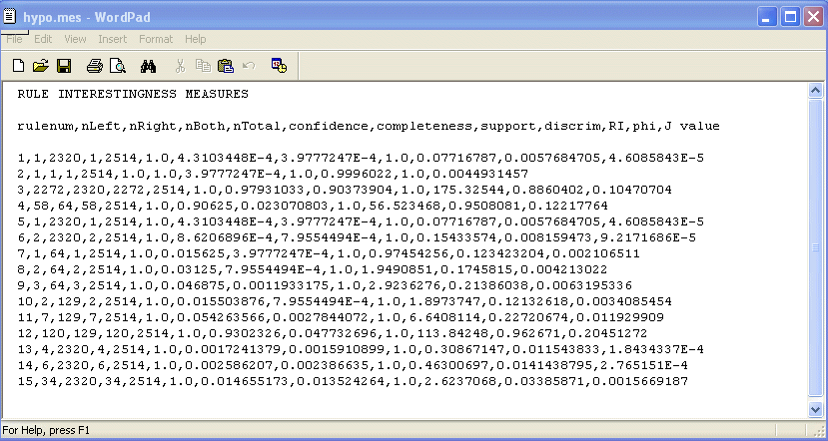

The contents of the file are in 'comma separated values' format. If desired, the file can be imported into a spreadsheet such as Excel for detailed analysis. (The files generated by the 'Save Exceptions' and 'Save Statistics' options can be processed in the same way.)

Now close the hypo.mes window, deselect 'Save Int. Measures' and 'Display Rule Int.' and restore the 'Rule Int. Measure' selection to RI.

Next select the vote dataset, which has a training set of 300 instances and a separate test set of 135 instances. Pressing the 'go' button will now generate 34 rules which correctly classify 126 of the instances in the test set, with seven wrongly classified and two unclassified.

We will now compare those results with those obtained using various types of cutoff. First click on 'Max Depth' to produce a menu.

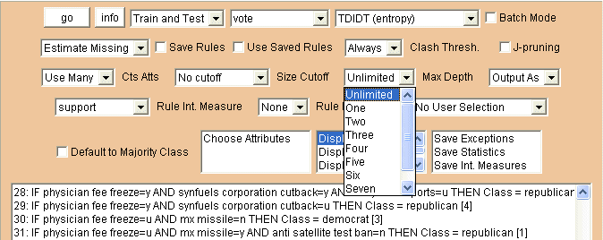

Select depths Three and Four in turn, pressing 'go' after each one to produce pre-pruned sets of decision rules.

A depth three cutoff gives 16 classification rules, which correctly predict 129 of the test instances, with six wrongly classified and none unclassified.

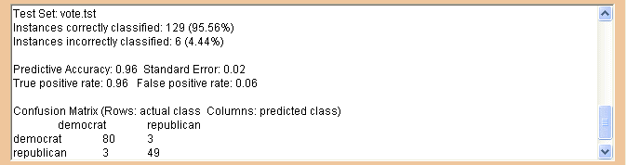

A depth four cutoff three gives 20 classification rules, which correctly predict 128 of the test instances, with seven wrongly classified and none unclassified.

Now reset Max Depth to 'unlimited' and click on Size Cutoff.

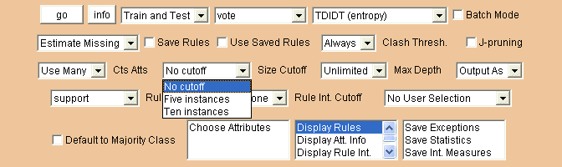

Select 'Five instances' and 'Ten instances' in turn, pressing the 'go' button after each one to see how each of the available size cutoffs performs, compared with the depth cutoffs or no cutoff at all.

Next, restore the 'Size Cutoff' option to 'No cutoff'.

We shall now look at some of the additional facilities provided for users via the Inducer 'options file' facility. Information about this is available as part of the online documentation available by clicking on the 'Documentation' link near the top of the screen.

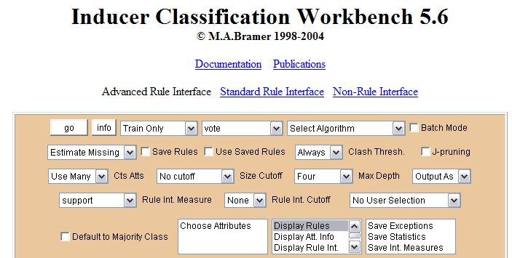

Clicking on 'Documentation' opens the online documentation in a new window.

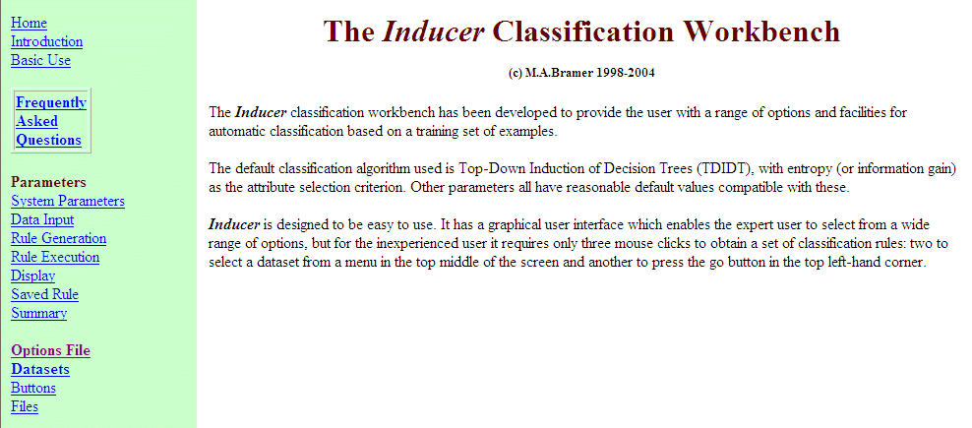

Clicking on the 'Options File' link on the left-hand side of the display produces documentation of the Options File facility.

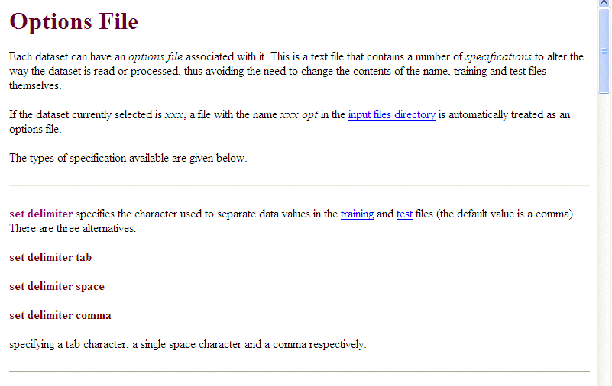

The options file, which in the case of the vote dataset would be named vote.opt and would be located in directory c:\inducer_data\outfiles\ comprises a number of lines of text, each either a comment or a 'specification' for Inducer.

Close the documentation window to go back to Inducer and press the 'View Options File' button at the bottom of the display.

Assuming the options file does not already exist, a new one will be created and opened in a new window, with just a comment line.

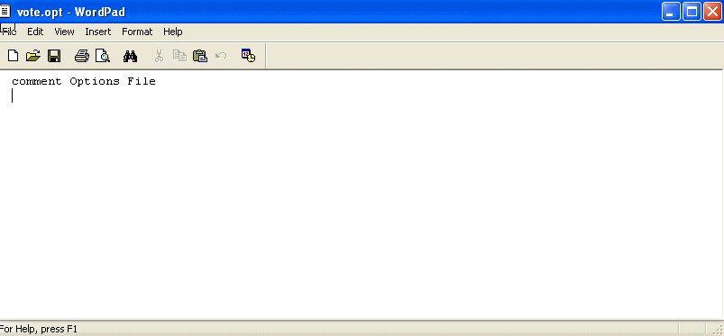

One of the specifications available is 'use instances'. This is used to indicate that only the specified number of instances in the training file for the current dataset should be read. The format is

use instances number

Note that this specification only affects the training file. If there is a separate test file and 'Train and Test' mode is specified, the whole of that file will be read.

Edit the vote.opt file by adding the line

use instances 200

Then close the window by clicking on the X in the top right-hand corner and answering Yes to 'Save changes to vote.opt?'.

Pressing the 'go' button will now cause Inducer to generate a classification tree based on only the first 200 lines of the training data.

The use of an options file is flagged to the user at the beginning of the upper text area.

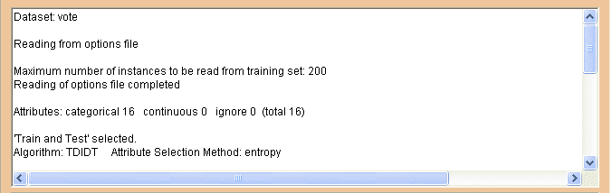

Edit the options file to remove the line

use instances 200

Next select the hypo dataset and press the 'View Options File' button to open file hypo.opt in a new window.

The hypo dataset has five classes: hyperthyroid, primary hypothyroid, compensated hypothyroid, secondary hypothyroid and negative.

There are 64 instances in the training set and 31 in the test set where the class is primary hypothyroid. If we wish to exclude them from consideration for any reason we can do so simply by adding the specification

ignore class primary hypothyroid

to the options file.

Edit the options file in this way and close the corresponding window. Then press the 'go' button to see the effect.

Now press 'View Options File' again to open the hypo.opt file. Remove the specification

ignore class primary hypothyroid

The distribution of classes in the hypo training data is very unbalanced. There are 2320 instances classified as 'negative' out of 2514. We may wish to consider all the other classes combined as a single class 'non-negative', giving a classification task to discriminate between just two classes: negative and non-negative. In Inducer terminology, but rather confusingly in this case, we consider 'negative' as the positive class and the other classes combined as the negative class in a two-class classification: positive versus negative. We can achieve this using the specification

make positive negative

Edit the file hypo.opt to add this specification, close the file and press the 'go' button.

The lower text area now refers to just two classes: negative and non-negative.

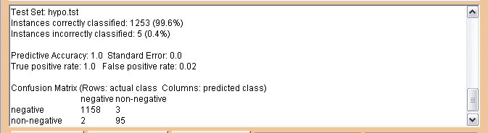

To complete this tutorial, edit the hypo options file to remove the line

make positive negative

and then exit from Inducer.

